QUARTERLY PROGRESS REPORT
CSO Name: SAF- TESO
Physical Address: Plot 1-7 PAMBA, OLIO ROAD, SOROTI CITY WEST
Reporting period:
Contact Information: (Executive director, program officer and Finance)
Name: Anguria Michael  Title: Executive Director  Email: shineafricaministries@gmail.com  Tel. No: 0781242684  Signature: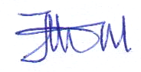 |  | Name: Apio Sharon  Title: Program officer (HTS F/P)  Email.apiosharon4004@gmail.com  Tel. No: 0789084004  Signature: | Name: Amuge Grace  Title: Accountant  Email:amugegrace89@gmail.com  Tel. No: 0787 812280  Signature: 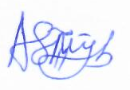
 | Date of submission: 10th/0ctober 2021

Contents
EXECUTIVE SUMMARY 2
Table 01: Out puts for the provision of HTS activities 6
a) The graph below summarizes Out puts on the provision of HTS activities 7
Table 02: Outputs on HTS for Key population. 9
a) The graph below summaries outputs on Key population activity 10
Table 02: Outputs to expedite the provision of antiretroviral therapy (ART) 11
b) The graph below summarizes outputs on follow-ups 13
c) The graph below summaries outputs for acceleration of access to EMTCT. 16
Community facility referral and linkages 16
Table 05: outputs on community facility referral and linkages 17
T.B Cascade 19
Table 06: outputs on TB 19
a) The graph below summaries outputs on TB activity progress per PHF 21
Table 07: outputs on home visits 22
b) The graph below summaries outputs on home visits 23
GBV interventions 24
Table 08: Out puts on GBV Interventions 24
d) The graph below summaries outputs on GBV intervention 25
Strategic Challenges and Risks faced during reporting period. 25
Technical Assistance Needed from TASO for Next Period 26
Governance, Management and staffing 27
Financial Summary 28
Performance Monitoring Plan 32
Conclusion 35

EXECUTIVE SUMMARY
Shine Africa foundation (SAF-Teso) is implementing a TASO Soroti region project sub-granted by TASO Soroti. aimed at accelerating HIV epidemic control through attainment of 95-95-95 UNAIDS targets by 2021.
With joint support and participation of community para - social workers and the health facility staff in the implementation period of July to September 2021. SAF Teso has continued to support health facilities in the areas of routine targeted mobilization of individuals for HIV testing and counseling through APN, Index client testing, ,outreach for key populations, conducting follow-ups of missed appointment and lost to follow clients, missed appointments of pregnant and lactating mothers, follow clients with non-suppressed viral load for intensive adherence counseling, follow-up of presumed TB clients, TB contact tracing and screening for TB, follow-up of GBV survivors, referral and linkage, screening for GBV and STIs.
The summary of key achievements in the reporting period is as per set objectives below:
To increase access to HTS by 95% to people living with HIV to get to know their status.
A total of 156 individuals were mobilized for HTS, 133 were tested and received their HIV status, 9 individuals tested positive and were linked to the nearby health facilities.
To contribute to retention by 95% of HIV clients into care and treatment.
A total of 112 clients missed appointment in public health facilities that SAF-Teso is attached to; 56 in kichinjaji, 29 in Tubur and 27 in Asuret HC IIIs.
A total of 45 clients were followed by SAF-Teso and all were brought back to care 17 to kichinjaji HC III, 18 to Tubur HC III and 10 to Asuret HC III.
A total of 50 clients were lost in the health facilities that we support 21 in kichinjaji HC III, 13 in Tubur HC III and 16 in Asuret HC III. 23 clients were followed and brought back to care, 8 to kichinjaji HC III, 5 to Tubur HC III and 10 to Asuret HC III.
49 clients were lost in the attached health facilities, 28 were followed and brought back to care 12 to kichinjaji health centre III, 9 to Asuret Health centre III and 7 to Tubur Health centre III.

To improve viral load suppression to 95%.
A total of 30 clients had non-suppressed viral loads as per health facilities supported, 11 for kichinjaji HC III, 14 for Tubur HC III and 5 for Asuret HC III.
And 9 clients with non- suppressed viral load suppressed after receiving IAC form the previous quarters, 5 in kichinjaji HC III, 3 in Tubur HC III and 1 in Asuret HC III.
To contribute towards the reduction of MTCT of HIV to less than 2%.
A total of 4 pregnant mothers were referred from community for antenatal and HIV testing services in the reporting period and 58 pregnant and lactating mothers attended PMTCT clinics at the health facilities.
Out of the 42 pregnant and lactating mothers who missed appointment, 36 were followed and brought back to care as per health centre, 16 to kichinjaji health centre III, 6 to Asuret Health centre III and 14 to Tubur health centre III.
Outputs on community facility referral and linkages
A total of 95 clients were referred to the health facility from the community. The categories included clients referred for Prep, PEP, family planning services STI testing and treatment, clients with opportunistic infections, TB contacts, presumptive TB clients, newly identified positives, clients who missed appointments, pregnant mothers referred for antenatal services, GBV, First aid services, HTS services among others.
13 clients were referred to the community from the health facility. These 10 clients were from CCLADS, and 3 GBV cases were referred to other service providers.
To reduce TB incidences and the burden on HIV clients with presumptive and diagnosed TB by 85%
Outputs of implementation include the following:
A total of 138 clients were screened for TB while conducting HTS, home visits, contact tracing and during clinic days at health facilities. Those who had anyone of the signs and symptoms of TB disease were referred for further TB test.

Presumptive and known TB clients
A total of 45 presumptive TB clients were followed and referred to health facility for TB test 18 to kichinjaji health centre III, 9 to Asuret health centre III and 18 to Tubur health centre III and 5 to Asuret HC III.
TB contact tracing
A total of 75 TB contacts were followed and referred to health facility for TB test, 29 to kichinjaji HC III, 23 to Asuret HC III and 23 to Tubur HC III.
19 clients were linked for IPT treatment, 17 to kichinjaji HC III, 0 Tubur HC III, 2 to Asuret HC III.
Outputs on home visits.
A total of 284 home visits were done when conducting follow ups for lost clients and those with missed appointments, provision of intensive adherence counseling, follow-up of GBV survivors for psychosocial support and provision of HTS services, TB contact tracing, follow-up of presumptive and known TB clients, while conducting assisted partner notification and index client testing. 8 BCC sessions were conducted while conducting outreach for KPS and integrated outreach for men and follow-up of pregnant and lactating mothers with missed appointment. Other services referred for were family planning services, SMC, provision of condoms and lubricants, STI and TB testing and antenatal services.
Out puts on GBV Interventions
However, this reporting period, 125 clients were screened for GBV both in community and facility during clinic days.7 were found to have experienced GB, 2 were linked to support agencies for support which included psychosocial counseling. first aid and 2 clients had experienced physical 0 experienced sexual violence and 5 emotional violence.

Strengthen referrals and linkages between HIV/AIDS programs and CSOs

Table 01: Out puts for the provision of HTS activities

 | No. of individuals Mobilized and counseled for HIV test | Total number of People tested for HIV | Number HIV positive Identified with Public Health facilities | % Yield | Number of newly identified HIV+ clients Linked to treatment
Male | 84 | 79 | 5 | 6.3% | 5
Female | 72 | 64 | 4 | 6.3% | 4
Total | 156 | 133 | 9 | 6.8% | 9

In the reporting period of July to September SAF-Teso with the support of the health facility team focused on providing HTS to micro targeted groups which included the key populations and priority populations, index clients, youth and adolescent girls, men 25 years and above. Services provided to these categories of people were partner elicitation, provision of prevention counseling, linkage to other prevention and care services e.g. antenatal, social support and prep initiation. however, a total of 156 individuals were mobilized for HTS, 133 were tested and received their HIV status, 9 individuals tested positive and were linked to the nearby health facilities.
A total of 20 individuals did HIVST in the communities and those who tested positive were referred to nearby health facilities for further test.

- The graph below summarizes Out puts on the provision of HTS activities

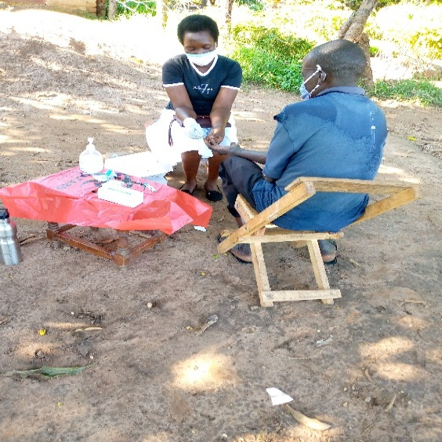
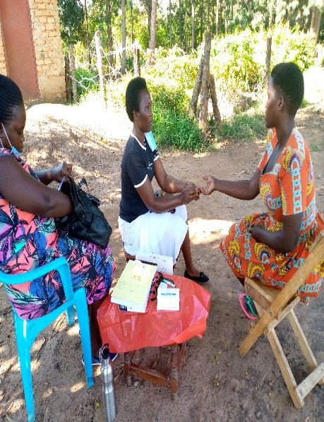
Figure 1:linkage facilitator of Asuret HC III while conducting outreach for men
Figure 2: linkage facilitator conducting APN testing. For kichinjaji HC III
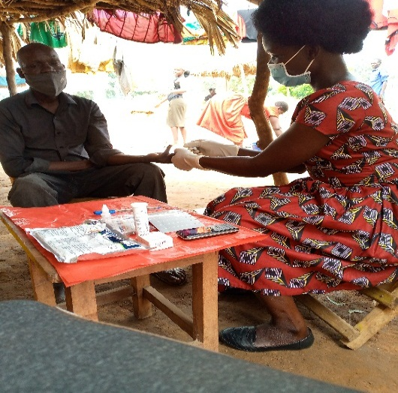
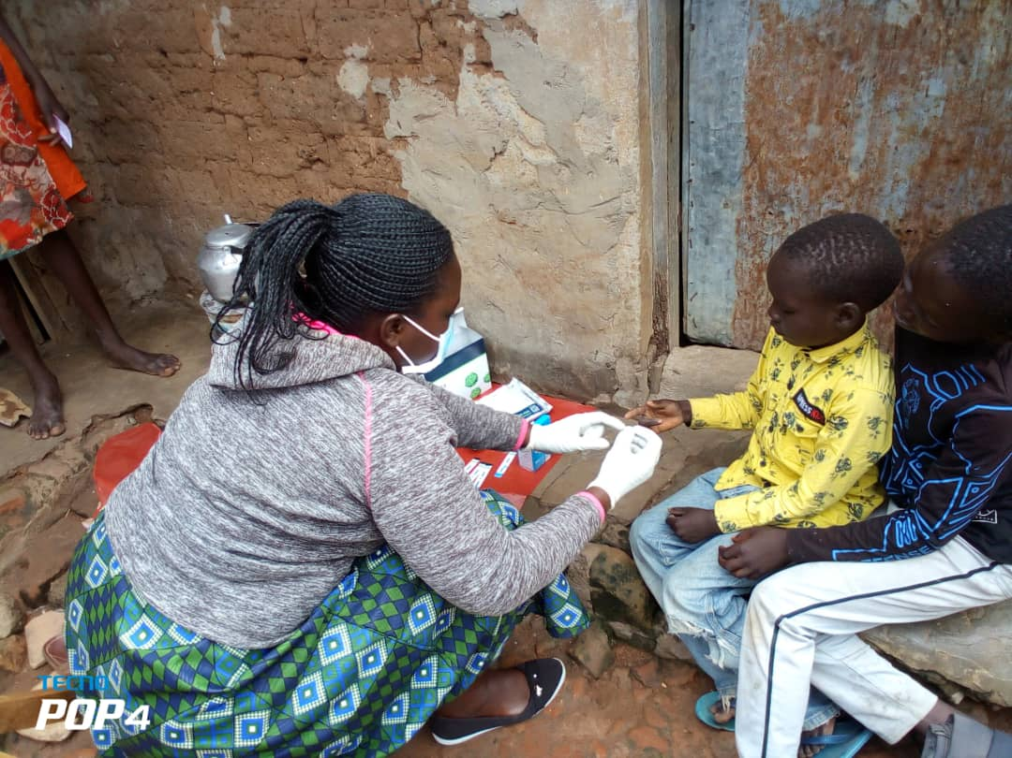
Figure 3:linkage facilitator of kichinjaji HC III while conducting index client testing.

Key population support

Table 02: Outputs on HTS for Key population.
Category of KPs mobilized for HTS | Total number of People tested for HIV | Number HIV positive Identified from hot spots | % Yield | Number of newly identified HIV+ clients Linked to treatment
FSW | 10 | 2 | 20% | 2
TOTAL | 10 | 2 | 20% | 2

Key and priority populations in Soroti district in include the sex workers, clients to sex workers, truck drivers, and drug users. however, our targeted interventions to these groups include HIV counseling and testing, Prep initiation, condom and lubricant distribution, health education.
Since these categories are burdened by HIV and contribute significantly to new infections, however, SAF-Teso has supported Kichinjaji health center III to provide services to KPs/PPs to increase access and uptake to health services and reduce stigma.
In this reporting period, a total of 10 sex workers were mobilized and tested for HIV using peer to peer approach, 2 positives were identified and linked to Kichinjaji health centre III other services offered were counseling, prep refill and condom distribution, TB and STI screening.

- The graph below summaries outputs on Key population activity

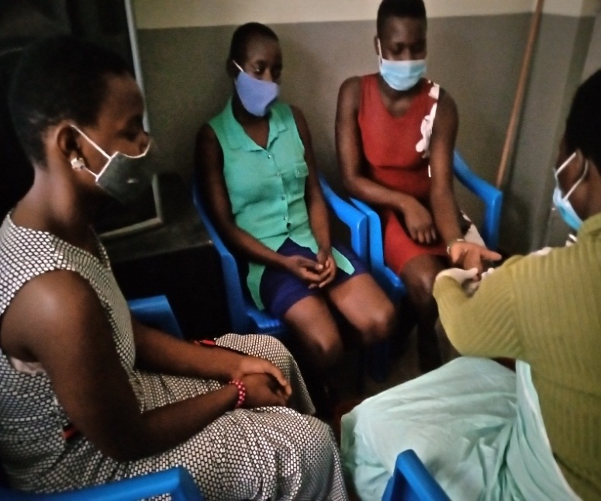
Figure 4:while conducting testing of female sex workers for kichinjaji health centre III

Clients follow-up

Table 03: Outputs to expedite the provision of antiretroviral therapy (ART)
Name of Facility | NO. of clients who Missed Appointments in the reporting period as per PHF | Number of clients followed up | No. of clients brought back into care after follow-up | No. of clients lost to follow up as per PHF | No. of clients followed up brought back to care | No. of clients with Non Suppressed Viral Load as per PHF | No. that received Intensive Adherence Counseling (IAC) | No. of Clients who got Viral suppression after IAC
Kichinjaji  HC III | 56 | 17 | 17 | 21 | 8 | 11 | 11 | 5
Tubur HC III | 13 | 18 | 18 | 13 | 5 | 14 | 14 | 3
Asuret HCIII | 27 | 10 | 10 | 16 | 10 | 5 | 5 | 1
Total | 112 | 45 | 45 | 50 | 23 | 30 | 30 | 9

The summary of achievement on retention
Over the previous implementation period, there has been tremendous improvement in the access to care and treatment in the facilities that SAF-Teso is supporting because the test and treat policy has been taken up. This reporting period however, the approaches used to conduct follow-up of clients to retention were home visits and phone call reminder for those with reliable phone contacts. Other services offered were counseling, STI, TB and GBV screening, linkage and referrals.
Activity progress for follow-up of clients with missed appointment lost and lost to follow clients.
A total of 112 clients missed appointment in public health facilities that SAF-Teso is attached to 56 in kichinjaji, 13 in Tubur and 27 in Asuret HC IIIs.
A total of 45 clients were followed by SAF-Teso and all were brought back to care 17 to kichinjaji HC III, 18 to Tubur HC III and 10 to Asuret HC III.
A total of 50 clients were lost in the health facilities that we support 21 in kichinjaji HC III, 13 in Tubur HC III and 16 in Asuret HC III.23 clients were followed and brought back to care.8 to kichinjaji HC III, 5 to Tubur HC III and 10 to Asuret HC III.
The following were barriers to ARV uptake, hence poor retention, these were; high transport costs to health facility caused by lock down, alcohol use, side effects, stigma and denial,
Follow up of clients with non-Suppressed Viral Load to provide intensive adherence counseling (IAC).
This reporting period, SAF-Teso has been offering systematic and routine IAC as scheduled in the clients’ appointment, one month apart. this is to help a client develop a comprehensive plan for adhering to ARVs by identifying their barriers to adherence, gaining insight of the barriers, exploring possible ways to overcome barriers and planning to adhere to treatment however there have been barriers to adherence for most of our clients which include health service factors, high pill burden, side effects, social economic status and stigma.
However, a total of 30 clients had non-suppressed viral loads as per health facilities supported 11 for kichinjaji HC III, 14 for Tubur HC III and 5 for Asuret HC III. and all the 30 clients were followed and provided intensive adherence counseling. And 9 clients with non- suppressed viral load suppressed after receiving IAC form the previous quarters, 5 in kichinjaji HC III, 3 in Tubur HC III and 1 in Asuret HC III.
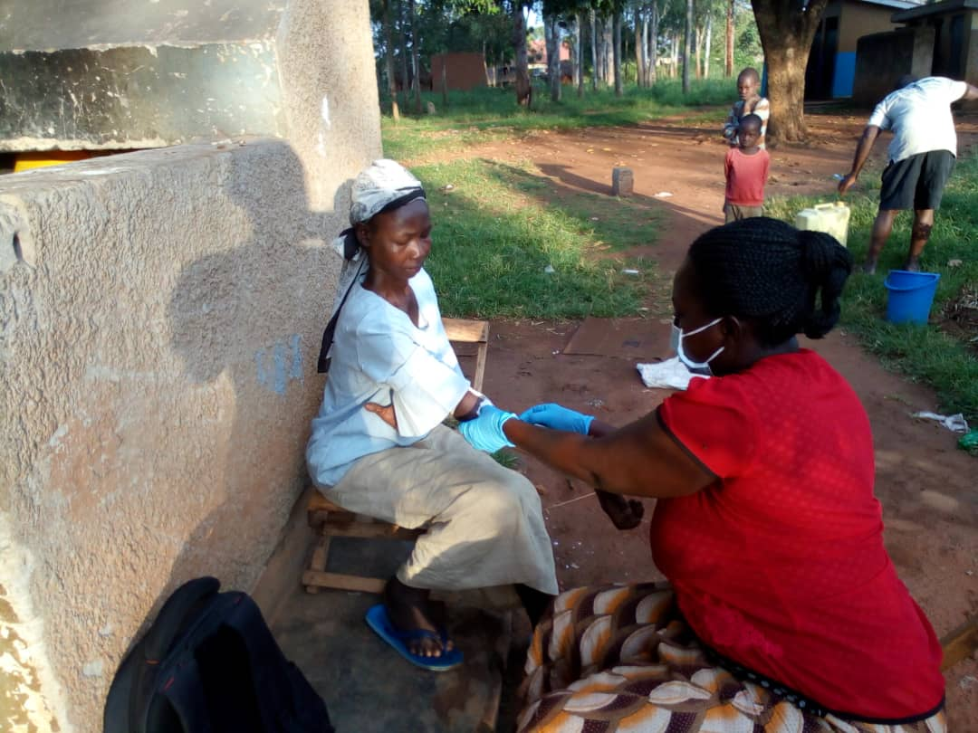
Figure 5:Linkage facilitator of kichinjaji HC III while bleeding client for viral load during home visit.

- The graph below summarizes outputs on follow-ups

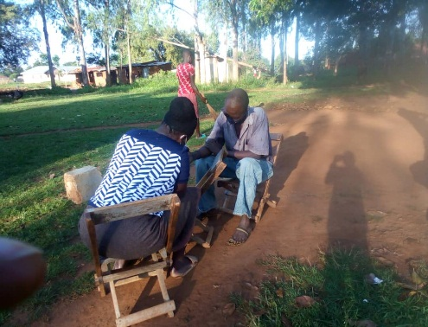
Figure 6:L/F while conducting follow-up of lost client.
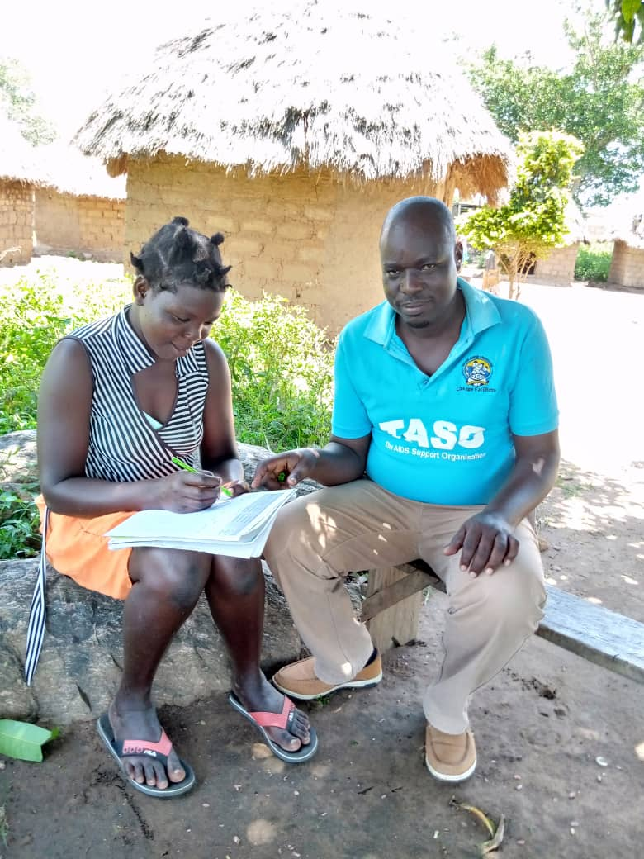
Figure 7:L/F of Tubur HC III while conducting follow-up of client with missed appointment

EMTCT
Table 04: Out puts for acceleration of access to EMTCT
Name of Health Facility | No of pregnant mothers identified from community and referred for HIV test  Female | No of pregnant & lactating mothers who attended PMTCT clinics | No of mother baby pair/HEIs Followed up and Linked to Facility 1st DNA/PCR test | No of HEI Followed up getting 2nd DNA/PCR test | No of HEI followed up for rapid HIV test at 18 months | Number of Pregnant and lactating Mothers who Missed Appointments | No. of Pregnant mothers who missed appointments Followed up and brought back to care
Kichinjaji HC III | 3 | 26 | 0 | 0 | 0 | 21 | 16
Asuret HC III | 1 | 11 | 0 | 0 | 0 | 8 | 6
Tubur HC III | 0 | 21 | 0 | 0 | 0 | 16 | 14
Total | 4 | 58 | 0 | 0 | 0 | 45 | 36

Outputs for acceleration for access to Emtct as per table above
This reporting period services offered towards Emtct were; Identification and referral of pregnant and lactating mothers for comprehensive ANC services, adherence support, community ART refills, HIV testing for partners, children and other family members and linkage to prevention and care services ART for HIV infected family members, TB screening, nutrition assessment counseling and support, sexual and reproductive health services including; family planning and condom distribution STI and TB screening and referral, adherence, disclosure and psychosocial support.
However low male involvement during antenatal care, delivery and post –natal services in the health facility has hampered elimination of mother to child HIV transmission. this therefore means in the event that the male partner is positive, there is high chance of infecting the mother and child.
SAF-TESO also provided services to non-pregnant women which included; routine HTS, BCC, STI screening, counseling adolescent girls and family planning.
Achievements towards SAF-Teso’s contribution towards the reduction of MTCT of HIV to less than 2%
A total of 4 pregnant mothers were referred from community for antenatal and HIV testing services in the reporting period and 58 pregnant and lactating mothers attended PMTCT clinics at the health facilities.
Out of the 42 pregnant and lactating mothers who missed appointment, 36 were followed and brought back to care as per health centre, 16 to kichinjaji health centre III, 6 to Asuret Health centre III and 14 to Tubur health centre III.

- The graph below summaries outputs for acceleration of access to EMTCT.

Community facility referral and linkages

Table 05: outputs on community facility referral and linkages
Name of Health Facility | No. of clients referred to the health facility from the community | No. of clients referred to the community from the health facility | Numb of clients on ART participating in a community refill model supported | % of appointments missed of clients receiving differentiated service delivery at community level
Kichinjaji HC 111 | 48 | 10 | 10 | -------
Tubur HC 111 | 33 | 3 | 0 | -------
Asuret HC 111 | 14 | 0 | 0 | -------
Total | 95 | 13 | 10 | -------

A total of 95 clients were referred to the health facility from the community. The categories included clients referred for Prep, PEP, family planning services STI testing and treatment, clients with opportunistic infections, TB contacts, presumptive TB clients, newly identified positives, clients who missed appointments pregnant mothers referred for antenatal services, GBV first Aid services, HTS services among others.
13 clients were referred to the community from the health facility. these were 10 clients in CCLADS, and 3 GBV cases referred to other service providers.

- Output on community facility referral and linkage

T.B Cascade

Table 06: outputs on TB

Name of Health Facility | No of clients/individuals screened for T.B in Community | No. of presumptive TB cases followed and referred to HF. | No. of clients diagnosed with TB | No of TB contacts followed | No. linked on IPT
Kichinjaji HC III | 54 | 18 | 0 | 29 | 17
Tubur HCIII | 44 | 18 | 0 | 23 | 0
ASURET HC III | 32 | 9 | 0 | 23 | 2
Total | 138 | 45 | 0 | 75 | 19
HIV is the strongest risk factor for developing TB disease. PLHIV are 20-37 times more likely to develop TB than HIV-uninfected individuals. TB is also the leading cause of HIV-related hospitalization and mortality. About 41% of all TB cases in clinical settings are co-infected with TB. Therefore, all patients with presumptive or diagnosed TB should be routinely screened for HIV and all PLHIV should be routinely screened for TB.
Outputs of implementation include the following:
A total of 138 clients were screened for TB while conducting HTS, home visits, contact tracing and during clinic days at health facility. those who had anyone of the signs and symptoms of TB disease were referred for further TB test.
Presumptive and known TB clients
A total of 45 presumptive TB clients were followed and referred to health facility for TB test 18 to kichinjaji health centre III, 9 to Asuret health centre III and 18to Tubur health centre III.
TB contact tracing
While conducting TB contact tracing, we focused on reducing TB infection at the community hence we followed contacts to all TB clients receiving TB treatment from the facilities that we support.
A total of 75 TB contacts were followed and referred to health centre for TB test, 29 to kichinjaji HC III, 23 to Asuret HC III and 23 to Tubur HC III.
19 clients were linked for IPT treatment 17 to kichinjaji HC III, 0 Tubur HC III and 2 to Asuret HC III.
- The graph below summaries outputs on TB activity progress per PHF

Figure 8: L/F while conducting TB contact tracing for kichinjaji health centre III.
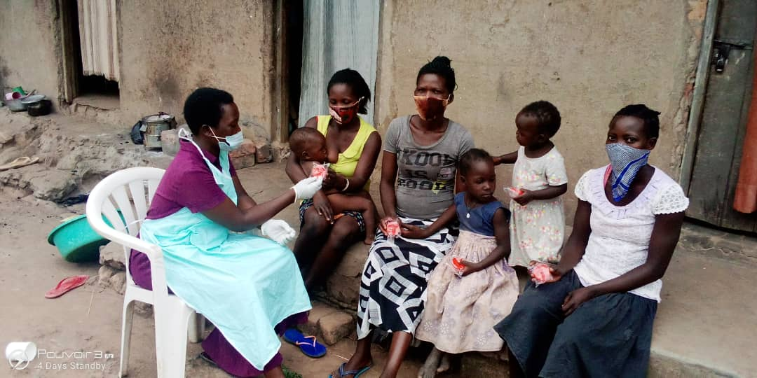

Home Visits

Table 07: outputs on home visits
Name of Health Facility | Number of home visits made | Number of BCC sessions for KP/PPs offered | Other services referred for | No. of running QI projects | No. of QI meetings held at CSO
Kichinjaji HC III | 111 | 4 | 3 | 0 | 0
Tubur HC III | 92 | 2 | 2 | 0 | 0
Asuret HC III | 81 | 2 | 2 | 0 | 0
Total | 284 | 8 | 7 | 0 | 0

A total of 284 home visits were made, these were during home visits for the lost and clients with missed appointments, provision of intensive adherence counseling, follow-up of GBV survivors for counseling and provision of HTS services, TB contact tracing, follow-up of presumptive and known TB clients, while conducting assisted partner notification and index client testing.
8 BCC sessions were conducted while conducting outreach for KPS and integrated outreach for men and follow-up of pregnant and lactating mothers with missed appointment.
Other services referred for were; family planning services, SMC, condoms and lubricants, STI testing, TB testing and antenatal services.

- The graph below summaries outputs on home visits

GBV interventions

Table 08: Out puts on GBV Interventions
No of individuals Screened for GBV | No. of GBV survivors followed | No. identified to have experienced GBV | No. Linked to support agencies e.g. Health Facilities | Number who received Services referred for | Number of documented referrals at the Community- Facility referral registers | No. of Individual who experienced Physical Violence | No. of Individuals who experienced Sexual abuse | No. of Individuals who experienced Emotional Violence
125 | 26 | 7 | 2 | 2 | 2 | 2 | 0 | 5
Total | 26 | 7 | 2 | 2 | 2 | 2 | 0 | 5

Follow up of GBV survivors
SAF-Teso and partners have been focusing on reducing incidences of violence as well as to reduce vulnerability to HIV/AIDS. The evidence on the linkages between violence against individuals and HIV/AIDS highlights that there are direct and indirect mechanisms by which the two interact. However Intimate partner violence poses indirect risk for HIV infection in several ways:
- Women with a history of violence may not be able to negotiate condom use, Childhood sexual abuse, coerced sexual initiation and current partner violence may increase sexual risk taking (e.g. having multiple partners, engaging in transactional sex), Women who experience violence may be in partnerships with older/riskier men who have a higher likelihood of being infected with STI and HIV; and Violence or fear of violence may deter women from seeking HIV testing, prevent disclosure of their status, and delay their access to AIDS treatment and other services.
However, this reporting period, 125 clients were screened for GBV at the community and facility during clinic days.7 were found to have experienced GBV, 2 were linked to support agencies for support which included psychosocial support. First aid and 2 clients had experienced physical violence, 0 experienced sexual violence and 5 emotional violence.

- The graph below summaries outputs on GBV intervention

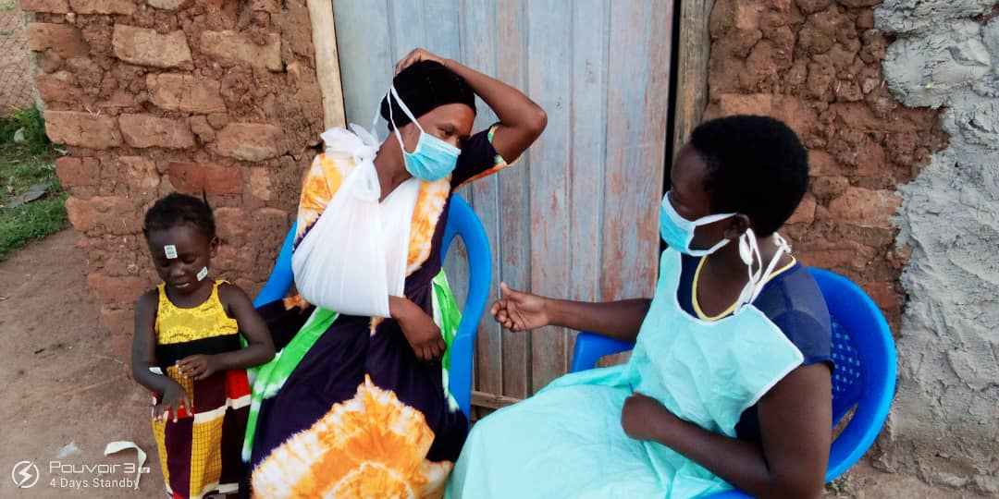
Figure 9: L/F for kichinjaji while follow-up of GBV survivor. During home visit.

Strategic Challenges and Risks faced during reporting period.
- Some clients do self-transfer, making follow ups difficult

- Some health facilities do not have updated client location /address/contacts hence making it hard to locate clients during follow-ups.
- Inadequate tools for monitoring and data storage at facility

Way Forward as per risks and challenges stated above (SAF-Teso).
- We request the IP to avail tools hence easing data management.
- We request facilities ART-in charges to strengthen a policy for clients acquiring transfer letters from facilities where they have been attending ART clinic in case of relocation should be strengthened.
- Technical Assistance Needed from TASO for Next Period
- Capacity building in all areas of our weaknesses
- Regular Support supervision
- Provision of tools

Governance, Management and staffing
SAF-TESO organization structure

AGM

Executive committee

Executive director

Program coordinator

Project officer

Accounts
Gender and community focal person
Health facility

COMMUNITIES AND PARA-SOCIAL WORKERS
Program vs. Financial Summary Tables

Financial Summary
- Balance from previous quarter: UGX
- Amount received this quarter: UGX 10,390,000
Funds utilized to date as per submitted bank statements: UGX
Planned Activity | Target allocated | Achievement | Variance of achievement | Funds allocated for the activity | Funds Spent to achieve the Out Puts | Comments
APN | Target sexual partners  Of 45 clients | 39 during APN testing 6 positives were identified 1 linked to Soroti and 3 to kichinjaji HC 111 1 to Tubur HC III and 1 to Asuret HC III |  | 600,000 | 600000 | 100% of funds allocated to conduct APN testing was used achievements were 39 enlisted sexual partners to clients were tested for HTS 6 positives were identified and linked to care.3 to kichinjaji HC III,1 to Soroti HC III, 1 to Asuret HC III and 1 to Tubur HC III
Mobilize and link index clients households for HTS | To mobilize 36 | 44 children tested  0positive |  | 360,000 | 360,000 | 100% funds spent to facilitate facility and cso staff to test 44 biological children to female clients during home visits 0 positive were identified..
Bi-weekly targeted outreach for men | 75 | 44 men 25 years and above were tested 2 positives identified |  | 360,000 | 360,000 | Funds were spent to facilitate cso and facility staff conduct outreach for men 44 men were mobilized for HTS during 2 positives were identified linked to kichinjaji HC III
Monthly targeted moonlight testing |  | 10 SW tested 2 positives identified |  | 320,000 | 240,000 | 10 sex workers were mobilized for HTS the hotspots 2 positives were identified and linked to kichinjaji HC 111.
Follow up of clients with missed appointment ,lost and lost to follow client | To follow 100 lost clients in reporting period | 45 clients were followed and brought back to care  23 lost clients were followed and brought back to care |  | 720,000 | 700,000 | 100% funds were spent to facilitate field work staff and CSO staff follow-up lost clients and clients lost to follow. for the facilities that SAF-Teso is attached to.45 clients with missed appointment were followed and brought back to care. 23 lost were also brought back to care
Formation and support of CCLADS groups and DSDM |  | 2 CCLAD groups supports |  | 120,000 | 120,000 | 100% funds were spent to facilitate field team supported the health facilities of kichinjaji in the formation, monitoring and follow-up .
Follow-up of presumptive known TB clients | Identify and follow 22 presumptive TB clients | 45 followed and referred to the health facilities for TB test |  | 360,000 | 500,000 | A total of 500,000 was spent facilitate CSO and facility staff with transport and SDA to follow know and presumed TB clients and refer them to the facilities 45 followed 18 referred to kichinjaji HCIII,9 to Asuret HC III and 18 to Tubur HC III
TB contact tracing | Follow 30 all contacts of TB clients in the reporting period | 75 TB contacts followed and referred for TB test. | 0 | 720,000 | 700,000 | 100% funds spent to conduct contact tracing for 75 TB contacts and referred to health facilities for TB testing. services offered were screening, counseling of family members and sensitization on TB. And referred to the following Health facilities.25 to kichinjaji,23 to Asuret HC III,16 to Tubur and 23 to Tubur HC III.
Follow-up of missed appointment of pregnant and lactating mothers | Follow-up 30 all missed appointments of pregnant and lactating mothers | 51 pregnant and lactating mothers with missed appointment followed and brought back to care. |  | 720,000 | 700,000 | 51 Pregnant and lactating mothers who missed appointment and brought them back to care .26 to kichinjaji HC 111,11 to Asuret HC 111 and 14 to Tubur HC 111.
Follow-up of GBV survivors | Follow GBV survivors 15 | 26 GBV survivors followed. |  | 360,000 | 420,000 | Funds were used to facilitate team follow 26 GBV survivors and offer psychosocial support, HTS and referrals for other services
Follow-up of clients with non - suppressed viral load for IAC | 100% of non-suppressed clients followed-up and provided IAC | 30 provided IAC | - | 600  ,000 | 580,000 | Funds were spent to follow 30 clients with non-suppressed viral load and provided intensive adherence counseling for three complete sessions.

Performance Monitoring Plan
Goal/Objectives/Outcomes/Activitys | Performance Indicators | Target | Performance |  | Narrative performance
 |  |  | CurrQtr  (1st April to 31st june 2021 ) | Cum
To increase access to HTS by 95% by 95% of the population living with HIV to know their status by 30th sept 2021
Community HTS | Number of individuals counseled, tested and received HIV results at the targeted community service point | 45 APN, 62 KPS, 36 index household, 75 men 25years and above provided HTS. | .  39 during APN testing 6 positives were identified 1 linked to Soroti and 3 to kichinjaji HC 111 1 to Tubur HC III and 1 to Asuret HC III  44 children tested  0positive  44 men 25 years and above were tested 2 positives identified  10 SW tested 2 positives identified |  | 39 during APN testing 6 positives were identified 1 linked to Soroti and 3 to kichinjaji HC 111 1 to Tubur HC III and 1 to Asuret HC III  44 children tested  0positive  44 men 25 years and above were tested 2 positives identified  10 SW tested 2 positives identified
To
To contribute towards the reduction of MTCT of HIV to less than 2% of positive pregnant and lactating mothers by 30th September 2021
Follow-up of missed appointments of pregnant and lactating mothers | No. of mother baby pair followed with missed appointments | 30 | 42 followed and brought back to care. |  | 45Pregnant and lactating mothers who missed appointment and brought them back to care .23 to kichinjaji HC 111,14 to Soroti HC 111 and 8 to Tubur HC 111.
To contribute to retention by 95% of HIV clients into care and treatment by 30th September 2021.
Follow-up of clients missed appointment and clients who are lost | Number of lost clients followed and brought back to care | 100 | 45 clients with missed appointment followed and brought back to care.  23 lost clients followed and brought back to care. |  | 45 clients with missed appointment followed and brought back to care.  23 lost clients followed and brought back to care.
Formation and support of CCLADS groups and other DSDM |  | 9 | 2 groups supported. | 6 | SAF-Teso supported the health facilities of kichinjaji and Soroti in the formation, monitoring and follow-up of 2 CCLAD groups in kichinjaji HC III
To improve viral load suppression to 95% by 30th September 2021.
Follow-up clients with Non-Suppressed viral load | No. of clients with non-suppressed VL followed and provided with IAC | 100% of non-suppressed clients followed-up and provided IAC | 30 followed for IAC.  9 clients suppressed |  | 30 clients with non-suppressed viral load and provided intensive adherence counseling for three complete sessions
To reduce the incidences and the burden on HIV clients with presumptive and diagnosed TB by 85% by September 2021
Follow-up of presumptive and known TB cases | No. of known presumptive TB clients followed | 22 | 40 presumed clients followed and referred to health facility. | --- | 40 followed 15 referred to kichinjaji HCIII,9 to Soroti HC III and 16 to Tubur HC III
TB contact tracing | Number of TB contacts followed | 30 | 138 screened for TB,45 were presumed and referred to HF,75 TB contacts followed and referred to HC ,19 linked for IPT. |  | 138 screened for TB,45 were presumed and referred to HF,75 TB contacts followed and referred to HC ,19 linked for IPT.
To reduce incidences of HIV by GBV management by September 2021
Follow-up of GBV survivors | Number of GBV survivors followed. | 15 | 26 |  | 26 GBV survivors and offer psychosocial support, HTS and referrals for other services
Community-Facility linkage and referral
 | # of individuals referred to HF | All clients |  | - | These included all the newly tested positives linked to the PHF,GBV cases identified and linked to health facilities for treatment, presumed TB clients

